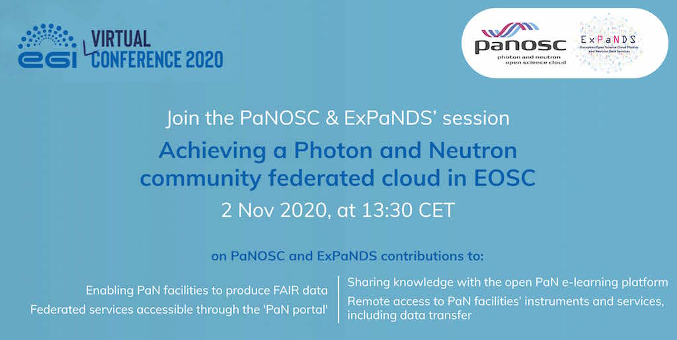

**Join the PaNOSC and ExPaNDS session at the EGI conference 2020**

[PaNOSC](http://panosc.eu/) and [ExPaNDS](https://expands.eu/) will contribute to the 2020 virtual edition of the [EGI conference](https://indico.egi.eu/event/5000/), with the panel session “[Achieving a Photon and Neutron community federated cloud in EOSC](https://indico.egi.eu/event/5000/contributions/14180/)”, taking place on 2 November 2020, from 13:30 to 14:45 CET.

**Join the session and** [**register here**](https://indico.egi.eu/event/5000/registrations/661/)

During the event, representatives of the two projects will present PaNOSC and ExPaNDS’ contributions to:

* Enabling PaN facilities to produce FAIR data;
* Federated services accessible through the 'PaN portal’;
* Sharing knowledge with the open PaN e-learning platform;
* Remote access to PaN facilities’ instruments and services, including data transfer.

**Speakers:**

* Andy Götz (ESRF)
* Patrick Fuhrmann (DESY)
* Brian Matthews (STFC)
* Alun Ashton (PSI)
* Nazaré Guimard (Soleil)
* Thomas Holm Rod (ESS)

With the theme “Federated infrastructures for connected communities” the EGI Conference aims to bring together science, computing, and (international) collaboration through a diverse and interactive [programme](https://indico.egi.eu/event/5000/timetable/#20201102) on topics spanning computing, data management, authentication-authorisation, and data analytics.